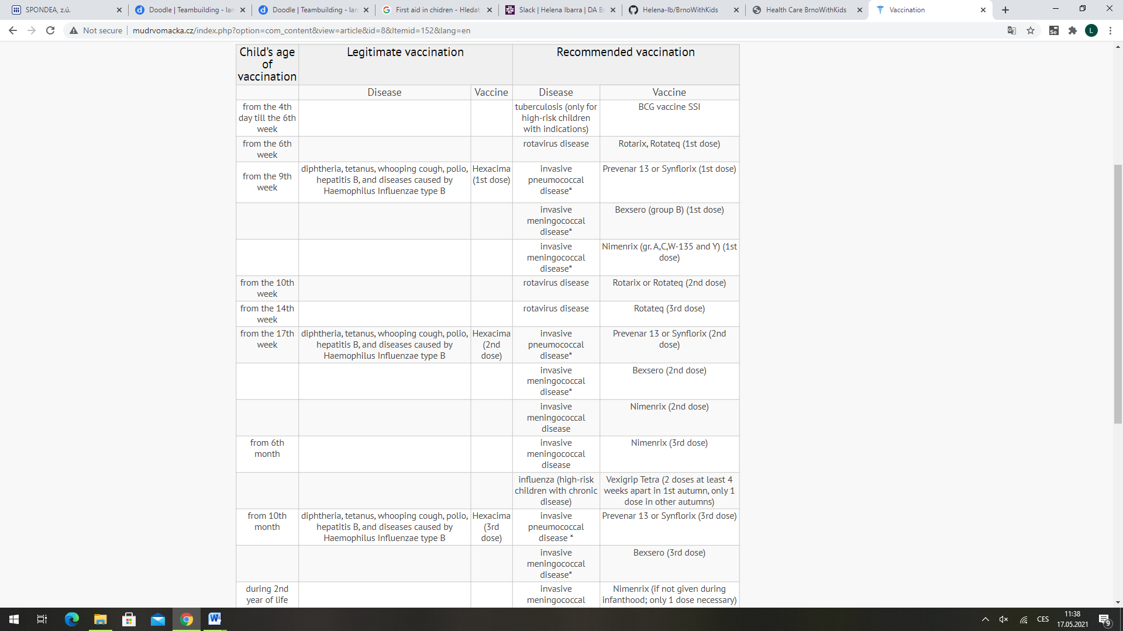

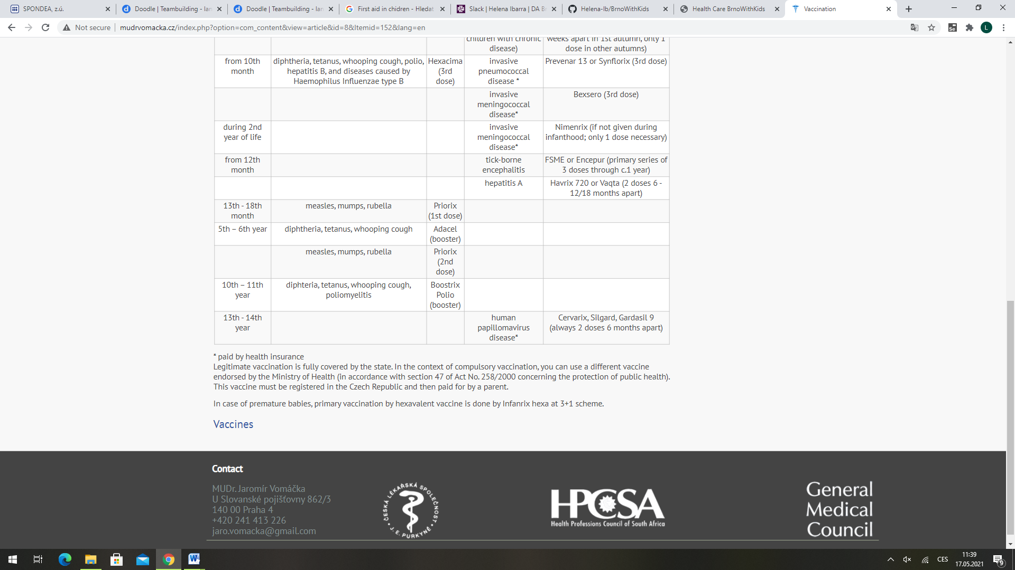

Vaccination against infectious diseases in the Czech Republic

Regular, special and emergency vaccinations against infectious diseases are provided to insured persons under the obligation of such persons to accept needed care. Vaccinations are provided free-of-charge.

The obligation to allow oneself to be vaccinated applies to the following persons:

- a natural person who is a permanent resident in the Czech Republic,  
- a foreign national who has been granted permanent residency status in the Czech Republic,  
- a foreign national who is entitled to permanent residence in the Czech Republic,  
- a foreign national who has been granted temporary residence in the Czech Republic for a period longer than 90 days or who is entitled to reside in the Czech Republic for a period longer than 90 days.

Children can only attend a nursery or preschool if they have received the required regular vaccinations, have evidence of immunity against a particular disease or evidence that they cannot be vaccinated due to a permanent contraindication (a prohibition against vaccination for health reasons).

Legitimate vaccination is fully covered by the state. In the context of compulsory vaccination, you can use a different vaccine endorsed by the Ministry of Health (in accordance with section 47 of Act No. 258/2000 concerning the protection of public health). This vaccine must be registered in the Czech Republic and then paid for by a parent.

In case of premature babies, primary vaccination by hexavalent vaccine is done by Infanrix hexa at 3+1 scheme.

Vaccination against infectious diseases in the Czech Republic